Explanation of how to get data for 28_bzone_travel_demand_management.csv
April 6, 2026
Definition of the Input File
VisionEval (https://visioneval.github.io/docs/model-inputs.html) explains that this file has two attributes: EcoProp (which is the proportion of workers who participate in “strong employee commute options” programs and ImpProp (proportion of households who “participate in strong individualized marketing program.” For example, consider Bzones 515400010001 (in an urban area of Charlottesville), Bzone 510030107021 (a suburban area near Route 29 in Albemarle County with some employment), and Bzone 510030110004 (a rural residential area in Albemarle County). The proportion of workers who participate in a strong employee commute options program is very small in all cases (less than 1%) and is zero for the rural area. For the proportion of households who participate in a marketing program to encourage nonauto modes, the proportion is still less than 1% and again zero for most rural zone.
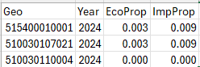
Possible Scenario
The document Task 7.2 Simplified Scenario Development guide, available at A Playbook for Simplified Approaches for Creating Scenarios in VisionEval, suggests that “Workplace programs include employee commute options (ECO) programs such as increased workplace bicycle parking, carpool and vanpool programs, or employer-subsidized transit passes. Individualized marketing (IM) programs are customized to traveler needs, such as the Portland Bureau of Transportation SmartTrips Program…Users may be interested in exploring how these programs in combination with other policies can impact driving, use of public or active transportation modes such as biking or walking, or car and vanpooling.”
Thus one may see how an increase in the proportion of employers who encourage alternative modes of transportation (e.g., increase EcoProp from 0% to 10%) may influence total VMT, walking trips, walking trip lengths, and walking person miles traveled.
Method Used for Virginia
Printed pages 63-66 of the VTRC report Feasibility of Adapting VisionEval for Scenario Planning, available at http://www.virginiadot.org/vtrc/main/online_reports/pdf/22-r21.pdf, show how a combination of a review of the literature and interviews with stakeholders can be used to define these attributes for a specific location. In sum, a nonzero value should not be assumed unless there is firm evidence of a solid program that encourages individuals to use non single occupant modes. Examples of such programs are financial assistance to purchase or rent a van for vanpooling (which would affect EcoProp), secure locker facilities for bicycling (also affects EcoProp), or direct in-person communications with residents to encourage non-auto use (which affects ImpProp).

The approach chosen here was to assume that both EcoProp and ImpProp are 0 unless there is a density of at least 4,000 people per square mile. (At the time the VTRC report was done, ImpProp was assumed to be 0 unless a bzone had this density, and this statewide dataset applies this logic to the EcoProp variable). Thus for the base year of 2024, the logic is:
- If the density is at least 4,000 people per square mile, then EcoProp has a value of 0.003 and ImpProp has a value of 0.009.
- If the density is less, than both EcoProp and ImpProp have values of zero.
Most of Virginia has a density lower than this amount as shown in yellow, with the red areas having a higher density than 4,000 people per square mile.
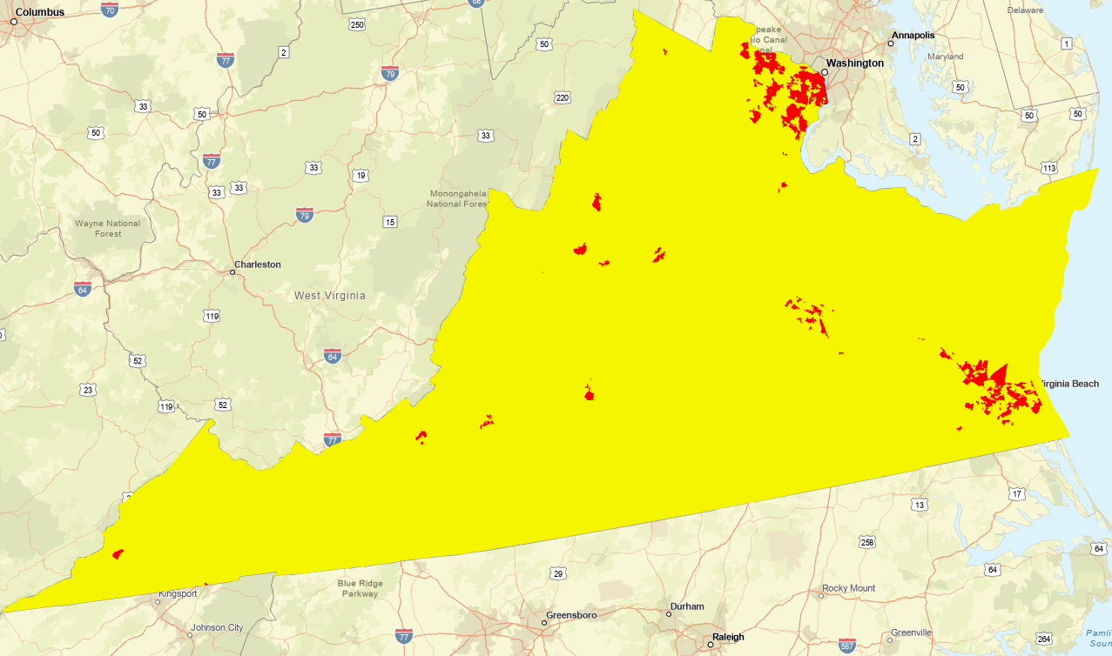
Figure. Areas with Red have Nonzero Values for EcoProp and ImpProp

Scrap Work
